Product Model : LA2 EU G4

Rev | Date | Description | Revised | Approved
A | 13 Oct 22 | First Released Draft

SECTION 1: GENERAL OVERVIEW

Project Name | LA2 EU G4
Cabinet Model Code | LA2-_E/S_ EU G4
Product Manager | Ramadhanul F. Yandra
Coordinator | Azheinita Eka Putri
Objective | To develop the high-level Class II BSC
Launch Date | TBD

No. | Aspect | Description | Remark
1. | Product Category | Biological Safety Cabinet
2. | Classification | Class II Type A2
3. | Feature and Price Level
4. | Target market | World, mainly EU and Asia
5. | Cabinet Size | 3, 4, 5, 6ft
6. | Code / Power Rating | 8
7. | Front Aperture Opening Height | 200 mm
8. | Designed to comply with the following standards | TUV
9. | Independent Certification by | TUV
10. | Controller | Centurion Touchscreen Controller
11. | LCD display | 7 inches
12. | UV lamp mounting | Back wall
13. | LED Light | LED 6500k dimmable

SECTION 2: MECHANICAL

# | ITEM | DESCRIPTION
A | General Design
1 | Design based on | LA2 G4 and AC2 TU
2 | Cabinet angle | 10°
3 | Front panel | Angled with side blue cover
4 | Design simplicity | Designed a simple as possible to safe time and cost in production.
5 | UV lamp mounting | Back wall
6 | External Dimensions (mm) | 3ft: 1035 x 858 x 1570  4ft: 1340 x 858 x 1570  5ft: 1645 x 858 x 1570  6ft: 1950 x 858 x 1570
7 | Gross Internal Dimension (mm) | 3ft: 915 x 623 x 720  4ft: 1220 x 623 x 720  5ft: 1525 x 623 x 720  6ft: 1830 x 623 x 720
8 | Usable Workzone (m²) | 3ft: 0.45  4ft: 0.62  5ft: 0.76  6ft: 0.93
9 | Maximum Shipping Dimensions WxDxH (mm) | 3ft: Tunggu update nya  4ft: 1520 x 950 x 1910  5ft: 1950 x 950 x 1910  6ft: 2200 x 960 x 1910
10 | Maximum Shipping Weight (kg) | 3ft: Tunggu update nya  4ft: 364  5ft: 378  6ft: 426
11 | Maximum Shipping Volume (m³) | 3ft: Tunggu update nya  4ft: 2.8  5ft: 3.5  6ft: 4.0
B | Steel Material
1 | Main body | 1.5 mm electro-galvanized steel with white oven-baked epoxy-polyester powder coated finish)
2 | Work Zone Construction | Stainless steel Type 304 with No.4 finish, 1.5 mm (0.06”) / 16 gauge thick
3 | Side Wall or Internal Liner Material | S:Stainless steel Type 304 with No.4 finish, 1.5 mm (0.06”) / 16 gauge thick. No VHP port.  E : 6 mm tempered glass ( follow Ac2 G3 format)
4 | Dress panel | N/A
5 | Work tray | S: Single piece, Stainless steel Type 304 with No.4 finish, 1.5 mm (0.06”) / 16 gauge thick  E : Multy tray, ( follow Ac2 G3 format)
6 | Arm’s rest | Stainless steel Type 304 with No.4 finish, 1.5 mm (0.06”) / 16 gauge thick
7 | Drain pan | Stainless steel Type 304, 0.7 mm, drain hole
8 | Base & drain pan design | New Style with EG draipan base
9 | Downflow diffuser | Alumunium non perforated
C | Perforation Details
1 | Tray front grille | All size = 4 rows of Ø 6.5 mm x 20 mm slots
2 | Inner liner back grille | All size = 1 row of Ø 8 mm x 20 mm slots
3 | Tray side grille | All size single tray = N/A  All size multi tray = 1 column of Ø 6.5 mm x 20 mm slots on the left and right side
4 | Downflow diffuser | All size = Ø 3 mm, pitch 5 mm.
D | Blowers & Plenum
1 | Plenum design | All size: Split plenum, same concept as AC2 TU
2 | Exhaust damper | N/A
3 | Blower/Fan | 3ft: Downflow Lau SIDD 10-4A with ½ HP motor. Exh: EBM DC motor D1G-146.  4ft: Downflow Airstream 102.9-9CLW with ½ Hp Motor. Exh: EBM DC motor D1G-146  5ft: Downflow Airstream 102.9-9CLW with ½ Hp Motor. Exh: EBM DC motor D1G-146  6ft: Downflow Airstream 104.10-9CLW with ¾ Hp Motor. Exh: EBM DC motor D1G-146
E | Filters
1 | Downflow
 | a. Supply Filter Pressure drop (Pascal) at rated airflow | 3ft: 96  4ft: 106  5ft: 106  6ft: 106
 | b. Supply Filter Rated Airflow (cmh) | 3ft: 726  4ft: 971  5ft: 1214  6ft: 1457
2 | Exhaust
 | - Exhaust Filter Pressure drop (Pascal) at rated airflow | 3ft: 79  4ft: 77  5ft:69  6ft:69
 | - Exhaust Filter Rated Airflow (cmh) | 3ft: 415  4ft: 564  5ft:750  6ft:846
 | - Prefilter Size (mm) | 3ft: 895 X 125 X 6  4ft: 1200 X 125 X 6  5ft: 1505 X 125 X 6  6ft: 1810 X 125 X 6
3 | Prefilter Qty | 3ft: 1  4ft: 1  5ft: 1  6ft: 1
E | Performance Test
1 | Noise Level as per
 | a. NSF 49 (dBA) | N/A
 | b. EN 12469 (dBA) | 3ft: 54.8 dBa  4ft: 55 dBa  5ft: 57.5 dBa  6ft: 58.0 dBa
2 | Light Intensity at zero ambient (lux) | 3ft: ≥1200  4ft: ≥1200  5ft: ≥1200  6ft: ≥1200
3 | Airflow
a. | Inflow (m/s); (fpm) | All size: 0.45 m/s (88.5 fpm)
b. | Downflow (m/s); (fpm) | All size: 0.32 m/s (63 fpm)
4 | Exhaust Characteristics | To Room / To Outside /
5 | Exhaust Ducting
 | a. Volumetric airflow Requirements for Exhaust Ducting (cmh/cfm) | N/A
 | b. Pressure Drop Requirements for Exhaust Ducting (Pa) | N/A
6 | Nominal Power (Watt) | 3ft: 167  4ft: 178  5ft: 285  6ft: 315
7 | Heat Load (BTU/Hr)  3.412142 x Nominal Power | 3ft: 570  4ft: 607  5ft: 972  6ft: 1076
8 | Stand by Power (Watt) | 3ft: 25 Watt  4ft: 27 Watt  5ft: 43 Watt  6ft: 47 Watt
9 | Maximum Power Consumption (Including the 5A Electrical Outlet) | 3ft: 1850 Watt  4ft: 1900 Watt  5ft: 1950 Watt  6ft: 2000 Watt
10 | Full Load Amps exclude 5A EO | 3ft: 10 A  4ft: 10 A  5ft: 10 A  6ft: 10 A
11 | Optional Outlets FLA | 3ft: 5A  4ft: 5A  5ft: 5A  6ft: 5A
F | Sash System
1 | Sash Window mechanism | Hinged Window With Motorized system
2 | Motorized window | Yes
3 | Sash glass | 3ft: 6 mm tempered glass  4ft: 6 mm tempered glass  5ft: 6 mm tempered glass  6ft: 6 mm tempered glass
4 | Cleaning behind window | Yes , by lifting the window 90°
G | Accessories
1 | UV lamp | Put on the back wall
2 | Service fixture holes | Staggered
3 | IV bar | Standard IV bar
4 | Regular support stand | SPEU, type A (28 inch for sitting mode) type B (36 inch for stand up mode)
5 | Nutsert for support stand | Use the new M8 nutsert with large flange and knurl to prevent loose nutsert
6 | Hydraulic support stand | N/A
7 | Arm's Rest PVC Padding | Chemically treated, improves operator comfort, easy to clean
8 | Foot Rest | Round Corner, Full EG structure, New locking concept, Easy manufacture pin
9 | Lab Chair | • Laboratory-grade construction, meets Class 100 cleanliness;  • Alcohol-resistant PVC materials  • Adjustable height 395-490 mm (15.6”-19.3”)
10 | Formalin Vaporizer | Dependable construction and innovative design  • Specifically designed for safety cabinet decontamination with automatic control
12 | BSC Decon Bag | Plastic decontamination bag for formalin decontamination on all BSC
13 | UV lamp | • Emission of 253.7 nanometers for most efficient decontamination  • Lamp is positioned away from operator’s line-of-sight for safety and proper  exposure to interior surfaces
14 | UV interlock kit | • Sash glass must be fully closed when turn on the UV
15 | Front Cover | 1.5 mm EG, with Isocide anti-microbial epoxy-polyester powder coating
16 | Electrical Outlet | European/ Worldwide Style, available in Type C, D, E, F, G, H, I  • North American style
17 | Service Fixture | • European/ Worldwide style  • North American style  • Electronic adjustable height, with levelling feet or casters

SECTION 3: ELECTRICAL & ELECTRONICS

# | ITEM | DESCRIPTION
A | Electrical Panel
1 | Electrical box design | New Design with cover (More perforation to aid cooling)
B | Components
1 | Speed control | Electronic serial control
2 | LED Lamp | 32-35.5VDC, 80CRI, 6500K
3 | LED Driver | 100-305VAC, Dimmable
4 | UV Ballast | 220-240VAC, 36W
5 | Control pad & LCD | Touch sreen
6 | Control board | Analog input/output, digital input/output
7 | SMPS | Input 85-264VAC, output 12VDC, 15W
8 | Airflow sensor | Input 11-13VDC, outout 0-10VDC, 0,2-2m/S
9 | Magnet switch | Normally open
10 | Micro switch | Normally open & Normally closed
11 | USB Port | Panel mounted USB2.0
12 | Wire harness | 105C, 300V
13

SECTION 4: SOFTWARE

# | ITEM | DESCRIPTION
A | Factory calibration | PIN = 00019
1 | Zero point | Will not be included in the calibration step
2 | Low inflow | At precisely 0.40 m/s, as measured using flow hood
3 | Nominal inflow | At precisely 0.45 m/s, as measured using flow hood
4 | Nominal downflow | At precisely 0.32 m/s, as measured using thermo anemometer
B | Field/simple calibration | The default calibration mode for certifier when they access the Menu
1 | Nominal inflow | At precisely 0.45 m/s, as measured using flow hood or hot wire anemometer
2 | Nominal downflow | At precisely 0.32 m/s, as measured using thermo anemometer
C | User interface
1 | Display | LCD Capacitive Touch 7 inch
2 | Multi language | English, Chinese, Finnish, French, German, Italian, Japanese, Korean, Spanish
3 | Standard buttons (on screen) | Menu, Fan, Lamp, Socket, Gas, UV, Mute
D | Displayed Information
1 | Standard display during normal running condition | Header: Cabinet State / Alarm Status  Body:  - Sash state on Safe Height  - Filter Life in %  - Downflow  - Inflow  Footer:  - Fan state, Lamp state, Socket state, Gas state, UV state, Mute state
2 | Standby Mode | Header: UV State  Body:  - Sash state on Standby Height  Footer:  - Fan state, Lamp state, Socket state, Gas state, UV state, Mute state
3 | UV Mode | Header: Cabinet State on Standby  Body:  - Sash state on Fully Closed  - UV Life in %  - UV Time  Footer:  - Fan state, Lamp state, Socket state, Gas state, UV state, Mute state
4 | Menu options | Press the Menu button on home screen.
5 | About | Press the BSC icon on home screen. This is for user to quickly access some info they may need.
E | Quick start mode
1 | Accessing this mode | Select Operation Mode from Menu options, and set to Quick Start
2 | When sash at Safe height | Blower turns on, warming up starts, and after warming up the Light turns on, UV Light is interlocked.
3 | When sash at Fully closed | Blower and light turn off and interlocked. UV light is not interlocked and able to be controlled
4 | Manual override | The blower, lamp, socket, UV button are enabled for manual override (turn off/on). If user lifts window, but doesn’t want fan to on, user can turn fan off. For safety, UV lamp still can’t be turned on when window is not fully closed.
F | Software Behavior
1 | Variant Selection | Can select the cabinet size and sash opening.  The selection is shown at the first cabinet is power on or after software installed, or can select from Cabinet Model page.
2 | Home page access | User have to login to access the home page screen.
3 | Lights during warm-up | by default it is OFF, but user can turn it ON by pressing the light button
4 | During warm-up | Air flows are not displayed, because sensors are warming up
5 | Alarm disabled mode | Activate from Airflow Monitor page. Warming up timer can be set to 0, 3, 5 and 15 minutes. During warm up, airflow velocity not displayed. After warm up, velocity is displayed, but no alarm.
6 | Calibration temperature | Cabinet temperature when the calibration process is carried out.
7 | Alarm enabled again | When alarm is enabled (Airflow Monitor is enabled) or again, warming up back to default of 3 minutes if the previous value is 0.
8 | The motorized sash jammed when moved down | Motorized sash will be stopped and moved up automatically for a few seconds
9 | The front cover is opened | Audible and visible alarm will be activated if the sash position is not at fully closed position

SECTION 5: NOTES AND ILLUSTRATIONS

- Centurion 7” Touch control panel:

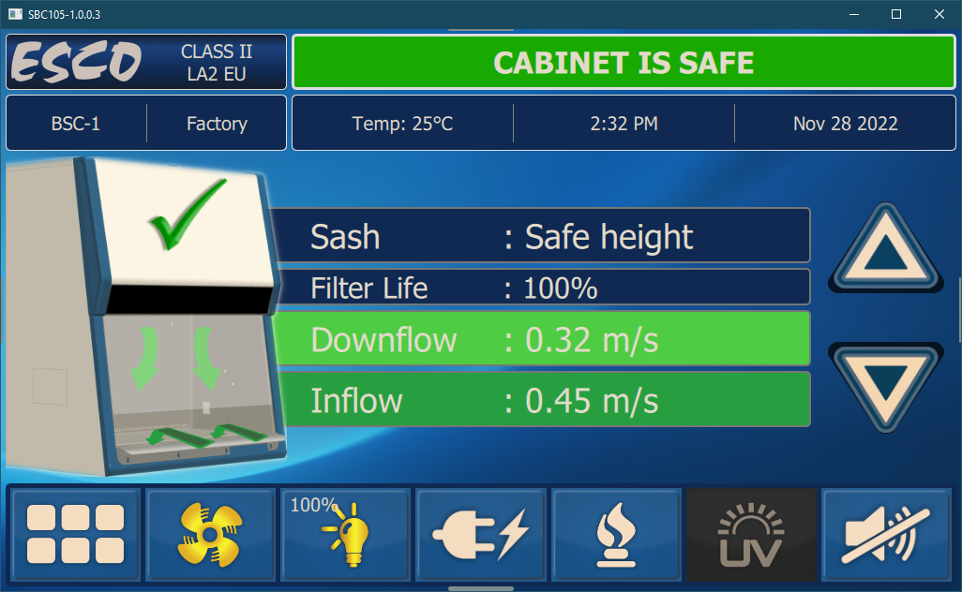

- Field Calibration using Offset Method:

The nominal point obtained by field certifier will replace the nominal point from factory. Unlike factory calibration, the field nominal point doesn’t have to be at exactly 0.45 m/s (90 fpm). It can be within ± 0.01 m/s (2 fpm) from 0.45 m/s (90 fpm).

The certifier doesn’t have to input the fail point, to make the job easier, faster, and less prone to calibration error caused by the ADC difference between nominal and fail point to be less than 80.

The fail point for field calibration is calculated from the field nominal point, and is offset based on:
a. The ADC difference between factory nominal vs. fail point,
b. How close the certifier can get the target nominal inflow of 0.53 m/s
c. Maintaining the fail point alarm at 0.40 m/s (79 fpm)

Below is an example of an inflow field calibration scenario, when the certifier:
a. Only managed to get 0.44 m/s inflow instead of 0.45 m/s inflow, according to his/her test instrument
b. Due to the tolerance of field vs. factory test instrument & measurement technique or uneven filter dust loading, the blower was set to higher speed, causing higher air velocity through the sensor, which gives higher ADC value.

Item | ADC | Measured (m/s) | ADC Values (Used for Example Only) | Keyed-in (m/s) | Displayed (m/s)
Factory zero point | IF0 | 0 | 0 | SET at 0.00 | 0
Factory fail point | IF1 | 0.40 | 2000 | SET at 0.40 | 0.40
Factory nominal point | IF2 | 0.45 | 2200 | SET at 0.45 | 0.45
Factory fail vs nominal | IF | 0.45-0.40=0.05 | IF = IF2 - IF1  IF = 2200 – 2000 = 200 | NA | NA
Field zero point | IF0 | = factory IF0 | 0 | NA | 0
Ex: Field nominal point | IFN | 0.44 | 2150 | 0.44 | 0.44
Then, the field fail point ADC is calculated as follows: | IFF | NA | IFF = IFN – (0.44-0.40) / (0.45-0.40) x IF  IFF = 2150 – (0.04/0.05) x 200  IFF = 2150 – 160 = 1990 | NA | 0.40
Optional:  Reset Field Calibration | NA | NA | IFF = IF1  IFN = IF2 | NA | NA

Using the algorithm above, the fail point ADC was offset from 2000 to 1990, to follow the new nominal ADC obtain in the field. We can diagnose calibration error by comparing the IFF & IFN (calibrated in field) versus IF1 & IF2 (calibrated in factory).

Optional: If the certifier thinks that he/she made a calibration mistake, and then uses the “Reset Field Calibration” function, the nominal and fail ADC will be reset to the original factory ADC. This is OK for new cabinet, but not for cabinet with loaded filters.

